Talavera Junior School

**Low-level Concerns Policy**



**Document Name: Low-level Concerns Policy**

**Document ID: n/a**

**Current Version: 2.0**

**Status:**

**Latest Review: September 2022**

**Next Review Planned: September 2023**

**Signed:_________________________ (Policy Owner)**

**Print Name:_____________________**

**Review Date:____________________**

**Signed:_________________________ (Governor Approval)**

**Print Name:_____________________**

**Approval Date:___________**

**Talavera Junior School**

**CHILD PROTECTION POLICY**

**POLICY CHANGE HISTORY**

|  |  |  |  |  |  |
| --- | --- | --- | --- | --- | --- |
| **Version** | **Date** | **Status** | **Policy Owner** | **Governor Approval** | **Comment** |
| 1.0 | Sept 2021 |  | HT |  |  |
| 2.0 | Sept 2022 |  | HT | RJ | Updates in line with Hampshire model |
|  |  |  |  |  |  |
|  |  |  |  |  |  |
|  |  |  |  |  |  |
|  |  |  |  |  |  |
|  |  |  |  |  |  |
|  |  |  |  |  |  |
|  |  |  |  |  |  |
|  |  |  |  |  |  |
|  |  |  |  |  |  |
|  |  |  |  |  |  |
|  |  |  |  |  |  |
|  |  |  |  |  |  |
|  |  |  |  |  |  |
|  |  |  |  |  |  |
|  |  |  |  |  |  |
|  |  |  |  |  |  |
|  |  |  |  |  |  |

**Low-Level Concerns Policy**

**Talavera Junior School**

Contents

Talavera Junior School 1

1. Introduction 6

2. Policy statement and aims 6

2. Summary and Definitions 7

5. Clarity around Allegation vs Low-Level Concern vs Appropriate Conduct 9

6. Storing and use of Low-Level Concerns and follow-up information 9

7. Process to follow when a Low-Level Concern is raised 11

8. Key Reference Document 12

9. Low Level Concern Form 12

# 1. Introduction

At Talavera Junior School, we take safeguarding very seriously. This includes ensuring that adults who work with children do so in a way that is in accordance with the ethos and policies set out by Talavera Junior School, including the Staff Code of Conduct. This policy sets out the detail and processes for staff regarding low-level concerns they may have. We recognise our statutory and moral duty to safeguard and promote the welfare or pupils. We understand that staff play a vital role in meeting these responsibilities. Our school works to ensure that we promote an open and transparent culture in which all concerns about adults working in or on behalf of the school are dealt with promptly and appropriately.

# 2. Policy statement and aims

**Policy statement**

Our school recognises its statutory and moral duty to safeguard and promote the welfare of pupils and understands that staff play a vital role in meeting these responsibilities. Our school works to ensure that we promote an open and transparent culture in which all concerns about adults working in or on behalf of the school are dealt with promptly and appropriately.

In this policy, the term ‘staff’ refers to all employees employed at this school including:

▪ Teachers

▪ Support staff

▪ Supply teachers

▪ Volunteers

▪ Local Authority visiting staff

▪ Contractors

**Policy aims**

* To help create a culture in which all concerns about adults are shared responsibly and with the right person and are recorded and dealt with appropriately.
* To enable schools to identify concerning, problematic or inappropriate behaviour early. To minimise the risk of abuse occurring.
* To ensure that adults working in or on behalf of the school are clear about professional boundaries and act within these boundaries and in accordance with the ethos and values of the school.
* To help create an environment where staff are comfortable to self-refer, where, for example, they have found themselves in a situation which could be misinterpreted, might appear compromising to others, and/or on reflection they believe they have behaved in such a way that they consider falls below the expected professional standards.

# 2. Summary and Definitions

It may be possible that a member of staff acts in a way that does not cause risk to children, but is however inappropriate. A member of staff who has a concern about another member of staff should inform the Head Teacher (Amanda Webb) about their concern using a Low-Level Record of Concern Form. If the Head Teacher cannot be contacted, the Chair of Governors (Robyn Jarrett) should be contacted instead.

**Definition**

**The term ‘low level’ concern does not mean that it is insignificant**. It means that the behaviour towards a child does not meet the harm threshold for an allegation.

**‘Keeping Children Safe in Education’** defines a low level concern as: “any concern – no matter how small, and even if no more than causing a sense of unease or a ‘nagging doubt’ – that an adult working in or on behalf of the school may have acted in a way that:

▪ is inconsistent with the staff code of conduct, including inappropriate conduct outside of work; and

▪ does not meet the allegations threshold or is otherwise not considered serious enough to consider a referral to the LADO”

3. Keeping Children Safe in Education September 2021

The following is taken from Keeping Children Safe in Education September 2021

As part of their whole school approach to safeguarding, Talavera Junior School should ensure that they promote an open and transparent culture in which all concerns about all adults working in or on behalf of the school (including supply teachers, volunteers and contractors) are dealt with promptly and appropriately.

Creating a culture in which all concerns about adults (including allegations that do not meet the harms threshold (see Part Four - Section one)) are shared responsibly and with the right person, recorded and dealt with appropriately, is critical. If implemented correctly, this should encourage an open and transparent culture; to enable Talavera Junior School to identify concerning, problematic or inappropriate behaviour early; minimise the risk of abuse; and ensure that adults working in or on behalf of Talavera Junior School are clear about professional boundaries and act within these boundaries, and in accordance with the ethos and values of the school.

**What is a low level concern?**

The term ‘low-level’ concern does not mean that it is insignificant, it means that the behaviour towards a child does not meet the threshold set out at paragraph 338. A low-level concern is any concern – no matter how small, and even if no more than causing a sense of unease or a ‘nagging doubt’ - that an adult working in or on behalf of the school may have acted in a way that:

* is inconsistent with the staff code of conduct, including inappropriate conduct outside of work; and
* does not meet the allegations threshold or is otherwise not considered serious enough to consider a referral to the LADO.

**Examples of such behaviour could include, but are not limited to:**

* being over friendly with children;
* having favourites;
* taking photographs of children on their mobile phone;
* engaging with a child on a one-to-one basis in a secluded area or behind a closed door; or,
* using inappropriate sexualised, intimidating or offensive language.

Such behaviour can exist on a wide spectrum, from the inadvertent or thoughtless, or behaviour that may look to be inappropriate, but might not be in specific circumstances, through to that which is ultimately intended to enable abuse.

It is crucial that any such concerns, including those which do not meet the harm threshold (see Part Four - Section one), are shared responsibly and with the right person, and recorded and dealt with appropriately. Ensuring they are dealt with effectively should also protect those working in or on behalf of Talavera Junior School from potential false allegations or misunderstandings.

# 5. Clarity around Allegation vs Low-Level Concern vs Appropriate Conduct

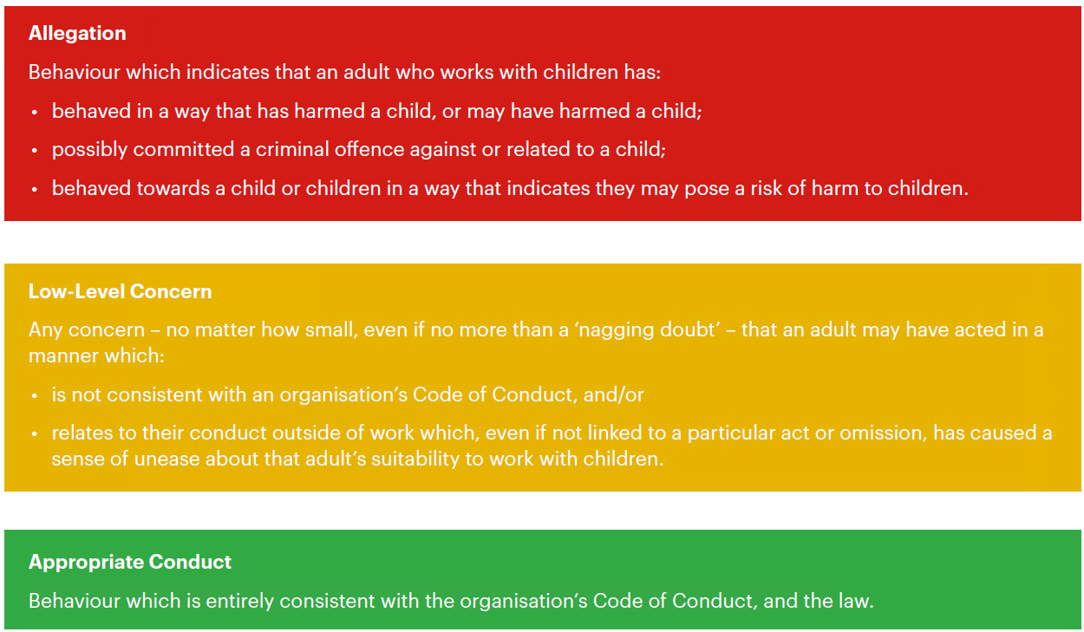

# 6. Reporting a low-level concern

Low-level concerns about a member of staff should be reported to the DSL and/or Headteacher and a ‘Low-Level Concerns’ form should be completed by the person reporting the concern. If the concern is about the Headteacher this should be reported to the Chair of Governors.

Low level concerns about supply staff, contractors and local authority visiting staff will also be reported to their employers upon completion of the ‘Low-Level Concern’ reporting form.

**Dealing with a low-level concern**

Where a concern is raised about the practice or behaviour of a member of staff, this information must be recorded and passed to the Headteacher. The Headteacher must then make an assessment to determine if the matter is a ‘low level concern’ or an ‘allegation’ and follow one of the following routes.

▪ Allegations that meet the harm threshold will be referred to the LADO for advice.

▪ Low level concerns that the school feel may need further guidance on will be referred to the LADO for advice.

▪ Low level concerns that the school feel they can deal with internally will be dealt with via the school’s usual child protection investigation process.

The school will engage with its HR provider where it is necessary to undertake further investigation and/or deal with the concern under relevant processes.

# 6. Storing and use of Low-Level Concerns and follow-up information

**Recording a low-level concern**

All low-level concerns should be formally recorded by a member of staff when they are made aware of them. This record should then be passed to the Headteacher (or Chair of Governors if the concern is about the Headteacher).

The record should include:

* details of the concern,
* the context in which the concern arose,
* the outcome of the investigation and any action taken, and
* the name of the individual sharing their concerns (if known) (unless the individual wishes to remain anonymous which must be respected as far as possible).

Relevant records will be retained confidentially on the personnel file. A separate record will also be kept of low-level concerns to more easily identify patterns that may involve more than one member of staff. All records must be kept in line with data protection principles.

**Reviewing a low-level concern**

Records will be reviewed so that potential patterns of concerning, problematic or inappropriate behaviour can be identified. Where a pattern of such behaviour is identified, the Headteacher will decide on a course of action, which may include:

▪ Disciplinary investigation and/or proceedings

▪ Management Advice, including recommendations for training Low Level Concerns Policy ▪ Referral to the LADO (where a pattern of behaviour moves from a concern to meeting the harm threshold).

The school will take advice, where appropriate, from their HR provider in respect of low-level concerns. The school will also review appropriate policies and training, or other wider cultural issues in the school, to see whether anything needs to be done to minimise the risk of similar behaviour happening again.

Relevant records will be retained confidentially on the personnel file. A separate record will also be kept of low-level concerns to more easily identify patterns that may involve more than one member of staff. All records must be kept in line with data protection principles.

Low level concerns will not be included in a reference unless they relate to issues which would normally be included in a reference (e.g. misconduct or poor performance). Low level concerns which relate solely to safeguarding will not be included in a reference. A low-level concern (or group or pattern of concerns) which has met the harm threshold and has therefore been referred to the LADO may be included in a reference depending on the circumstances.

Records will be reviewed so that potential patterns of concerning, problematic or inappropriate behaviour can be identified. Where a pattern of such behaviour is identified, the Headteacher will decide on a course of action, which may include:

▪ Disciplinary investigation and/or proceedings

▪ Management Advice, including recommendations for training Low Level Concerns Policy ▪ Referral to the LADO (where a pattern of behaviour moves from a concern to meeting the harm threshold).

LLC forms and follow-up information will be stored securely within Talavera Junior Schools safeguarding systems, with access only by the Senior Leadership Team. This will be stored in accordance with the school’s GDPR and data protection policies.

The staff member(s) reporting the concern must keep the information confidential and not share the concern with others apart from the Head Teacher or those aware in the Senior Leadership Team.

Low-Level Concerns will not be referred to in references unless they have been formalised into more significant concerns resulting in disciplinary or misconduct procedures.

Whenever staff leave Talavera Junior School, any record of low-level concerns which are stored about them will be reviewed as to whether or not that information needs to be kept. Consideration will be given to:

(a) whether some or all of the information contained within any record may have any reasonably likely value in terms of any potential historic employment or abuse claim so as to justify keeping it, in line with normal safeguarding records practice; or

(b) if, on balance, any record is not considered to have any reasonably likely value, still less actionable concern, and ought to be deleted accordingly.

The school will take advice, where appropriate, from their HR provider in respect of low level concerns.

The school will also review appropriate policies and training, or other wider cultural issues in the school, to see whether anything needs to be done to minimise the risk of similar behaviour happening again.

Relevant records will be retained confidentially on the personnel file. A separate record will also be kept of low level concerns to more easily identify patterns that may involve more than one member of staff. All records must be kept in line with data protection principles.

Low level concerns will not be included in a reference unless they relate to issues which would normally be included in a reference (e.g. misconduct or poor performance). Low level concerns which relate solely to safeguarding will not be included in a reference, subject to paragraph 10.2.

A low level concern (or group or pattern of concerns) which has met the harm threshold and has therefore been referred to the LADO may be included in a reference depending on the circumstances.

# 7. Process to follow when a Low-Level Concern is raised

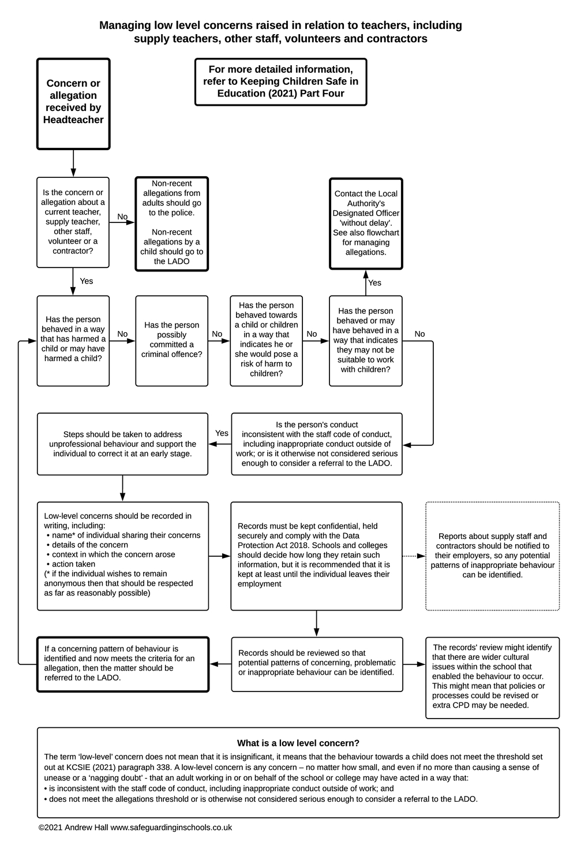

# 8. Key Reference Document

Read this document for further information about Low-Level Concerns, which is referenced in KCSIE 2021.

<https://www.farrer.co.uk/globalassets/clients-and-sectors/safeguarding/low-level-concerns-guidance-2020.pdf>

# 9. Low Level Concern Form

This form will be available to staff via :

* DSLs
* The Senior Leadership Team

**Related guidance**

The policy links to the following guidance documents:

▪ Keeping Children Safe in Education (DfE)

▪ Model Code of Conduct (Manual of Personnel Practice)

▪ Avoiding Allegation guidance (Manual of Personnel Practice)

▪ Safeguarding Policy (Safeguarding Unit)

▪ Child Protection Policy (Safeguarding Unit)

**Low-Level Record of Concern Regarding A Staff Member**

Please use this form to share any concern – no matter how small, and even if no more than a ‘nagging doubt’ – that an adult may have acted in a manner which:

* is not consistent with the Staff Code of Conduct, and/or;
* relates to their conduct outside of work which, even if not linked to a particular act or omission, has caused a sense of unease about that adult’s suitability to work with children.

Where possible please speak with the Head Teacher as soon as possible. It is also helpful to document your concerns, which can be done using this form and then passed to the Head Teacher. When completed, please pass this form to the Head Teacher. If the concern is about the Head Teacher, please pass it onto the Chair of Governors in a sealed envelope via pigeon hole or email the chair directly.

*Remember, a low-level concern is different to an allegation. See the table below for a definition:*

**

**Name of adult writing this concern:**

**Name of adult whom this concern is about:**

**Date written:**

**Signature:**

**Please write your concerns below (continue overleaf)**

You should provide a concise record – including brief context in which the low-level concern arose, and details which are chronological, and as precise and accurate as possible – of any such concern and relevant incident(s) (and please use a separate sheet if necessary). Consider any contextual information that may be appropriate to know.

Policy created on September 2021

Review on September 2022