

Talavera Junior School
Reading Policy

Document Name: Reading Policy

Document ID: N/A

Current Version: 6.0

Status:

Latest Review: September 2021

Next Review Planned: September 2022

Signed:_________________________ (Policy Owner)

Print Name: Catherine Oakes

Review Date: September 2022

Signed:_________________________ (Governor Approval)

Print Name:_____________________

Approval Date:___________________

Talavera Junior School
Reading Policy

Rationale
Reading is a multi-strategy approach to understanding the written word. It is not simply the decoding of black marks on the page but involves the ability to read with understanding a wide range of different texts, including fiction, non-fiction, real world texts such as labels, captions, lists and environmental print. Competence in reading is the key to independent learning and therefore the teaching of reading should be given a high priority by all staff. Success in reading has a direct effect on progress in all areas of the curriculum and is crucial in developing children’s self esteem, confidence and motivation.

Aims
Our aims are to encourage children to:
~ Read for interest, information and enjoyment
~Develop enthusiasm and confidence as readers who can understand a wide range of texts
~Develop the ability to read aloud fluently and with expression;
~Develop the ability to read for meaning;
~Develop the skills required for the critical reading of texts;
~Be encouraged to read a wide range of fiction, poetry and non-fiction materials;
~Be taught and orchestrate full of cueing strategies for reading including:
- Phonic (sounding the letters and blending them together);
- Visual (whole word recognition and analogy with known words);
- Contextual (use of picture and background knowledge);
- Grammatical (which words make sense);
These to be taught during shared and guided reading.
~Be encouraged to listen attentively;
~Gain awareness of the close links between reading and writing activities.

Practice
We will therefore provide the following reading experiences and environments to achieve our aims:

Shared Reading
In class reading the teacher’s role is to make overt what good readers do. In particular there will be an increased emphasis on fluency. During shared reading the children can access a text which may be challenging to them individually. Reading skills and strategies should be clearly modelled, and discussion should help children to a deeper understanding of the text. Shared reading should have a specific focus and all abilities should be included in discussions by differentiated questions. This should be developed through reading journey session daily, a class reader and in English lessons when discussing the text.

Independent Reading
Children need to be given the opportunity and encouragement to read independently in order to build confidence, stamina and fluency, as well as develop their experience of a range of books and authors.

Children should have access to a wide range of books including fiction and non-fiction via the school library, e-reader, the Schools’ Library Service and School Book Fairs. School library service books are exchange termly to provide variety and specifically requested texts. Senior Librarians are responsible for collecting requests from each class. Years 4 and 5 take part in Hampshire Book award initiatives each year, analysing and reviewing books selected at county level.

All children will have free access to an e-reader through the SLS subscription. New starters will be shown how to log on in school and a guide will be sent home with them to promote access at home through their own tablet/device.

All children below the expected level at KS1 will be benchmarked and SALFORD assessed in order to gauge reading ability and assigned a book band. Where appropriate a dyslexia screening may take place and dyslexia-friendly texts will be recommended. These are clearly labelled in the free-reader section and the main library. Reading overlays are also available when reading other texts. Dyslexia settings can be applied to the e-reader and all paper copies of the screening are to be photocopied onto cream paper to reduce visual stress..

Children in KS2 should be encouraged to take home two books from the school library in addition to a book from the banded section of the library if necessary. Children in years 5 and 6 will be given the opportunity to take 3 books. All classes will visit the library for a slot once a week where the children can change their book, read quietly or work on one of the library task cards independently or with a friend. This should be an opportunity for the class teacher to teach the skill of selecting a book or to read with children who do not read frequently at home.

Selecting their own choice of texts is an important part of developing independence. As children move onto becoming a free reader they will begin by selecting their own book from the free reader section which allows them free choice within a range of suitable texts. Selecting texts motivates readers and helps children to develop and discuss their reading preferences. Teachers should be teaching children how to choose an appropriate text for their reading ability and tests they can carry out when making that choice.

The book will be taken home, together with a reading record. Children’s individual reading will be monitored by staff and supported by classroom assistants. Each time a child reads at home the class TA will take note of how many reads they have completed and award certificates and/or rewards as appropriate. Where children do not read regularly at home teachers will arrange for them to read individually at school to parent helpers, classroom assistants or older children.

Reading should not be seen as just a ‘school activity’. Wider family involvement supports reading and ensures children have access to reading materials at home. Where possible Parent/Child Reading Workshops will be provided to support development and enjoyment of reading at home.

Reading Environment
Classrooms and all school areas should provide a print rich environment. Reading displays should form a part of that environment – library corners, favourite books, book reviews, book of the week, author displays and collections of books on a similar theme will help to develop enthusiasm.

Book corners should have a wide range of books available for all reading abilities. Children should be encouraged to choose an appropriate book for their ability.
The reading area should be an inviting and children orientated area, which the children are involved in creating.

Assessment, Recording and Reporting
All children are screened as part of the Special Needs Screening in Year 3 and during the year across the Key Stage using the appropriate Salford Reading Test. Regular termly assessment is carried out by the Special Needs Department, to monitor the progress of all children.

Consultation with the SENCO is essential to ensure children are placed on programmes appropriate to their needs. Where children are identified as requiring additional support, their parents will be informed and they will be involved in the Reading Support Programme delivered by Teaching Assistants. Parents will be notified by letter that their child is receiving additional support.
In extreme cases where a child’s reading is significantly delayed, and being part of a Reading Intervention Group would not benefit their reading development, children will be assessed to identify their specific reading needs and qualified assistants will provide a programme of support that caters for the individual needs.

English as an Additional Language
All staff should take into consideration that:
~New arrivals to the UK may come from a different tradition of reading materials and styles
~Different cultures may give a different value to books/have different access to books
~All children and cultures may have different styles of learning to read (e.g. have different sound systems, familiarity with phonics, different scripts, orientation of texts and books)
~ Children may be able to read mechanically very effectively, without actually accessing meaning- this should be taken into account when deciding appropriate assessment methods/reading tests
~ Inferring meaning and reading between the lines is a particularly difficult skill for pupils with EAL and requires sufficient time and practice needs to be given to support acquisition of these skills
~Quality of reading aloud may be affected as children acquire English pronunciation and intonation patterns
~Some languages are read exactly as written, others like English, more variation (eg tough, although, through, thought) so consideration of this should be made, when developing activities for reading.

Parent Reading Workshops
We aim for every child to be a reader and therefore reluctant readers will be invited along with their parents to a 20 minute after school reading workshop. This will encourage parents to read at home with their children on a particular book which is provided by the school. The family will receive a free book and a pack of tasks which link with the text. This will promote the relationship between the school and the parents, strengthening the home-school link and also encourage children to read at home with a family member to further their progress. A second follow up session will then be run in order for the child to share and be celebrated on their success.

Co-operation and support from parents is paramount if a child is to become a successful and competent reader. At Talavera Junior School we strive to develop and encourage a strong partnership between home and school. It is our policy to send reading books home regularly and to encourage parents and carers to contribute to their child’s reading development, welcoming comments in individual reading record book.

Catherine Oakes
Library Manager
September 2021
Review date: September 2022

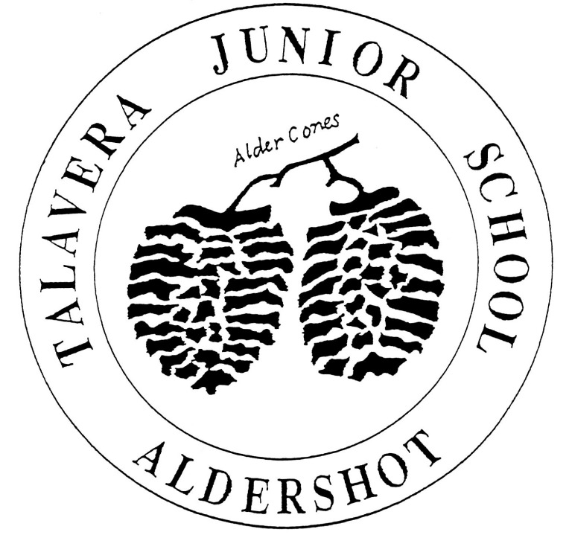

Talavera Junior School
READING POLICY

POLICY CHANGE HISTORY

Version | Date | Status | Policy Owner | Governor Approval | Comment
1.0 | October 2009 |  | Claire Furzland
2.0 | December 2014 |  | Maxine Cutforth
3.0 | November 2015 |  | Maxine Cutforth
4.0 | August 2016 |  | Maxine Cutforth
5.0 | September 2017 |  | Maxine Cutforth
6.0 | September 2018 |  | Maxine Cutforth

