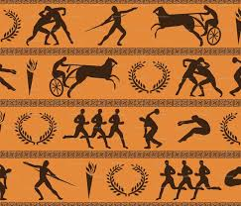

**Happy New Year**

The Year 4 team have been truly amazed by the progress our children have made since September. I would also like to take this opportunity to thank again the parents who came to our times table workshop – we are really noticing a difference in their times table recall. Please continue to regularly practise times tables with their children in preparation for the government test in June.

This half-term, we will continue to explore the Ancient Greeks within our history lessons. However, this will now focus more on the geographical side and the Ancient Greeks’ position in history. We will also have a focus on healthy living and eating this half term. Within Science and PSHE, we will explore what makes a healthy diet as well as finding out about how to keep our teeth clean and how we digest our food. In addition to this, children will also spend their French sessions learning the names of body parts in French.

**YEAR 4 NEWSLETTER**

**Spring term 1: Let the Games begin**

44

|  |  |  |
| --- | --- | --- |
| English - Greek myths and legends  Jabberwocky  Class Reader: Alice in Wonderland (a range of picture and poetry books)  A range of non-fiction Ancient Greek books | Science – Teeth and Eating  Computing – Scratch  Music – Listen 2 Me music  (Brass or African percussion)  French – My Body  History – Ancient Greeks | Indoor PE – Dance  Outdoor PE – Cross country  Art – The work of Keith Haring  DT – wire sculptures/ cooking and nutrition  PSHE – Healthy Eating  RE – Good and Evil |

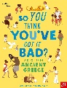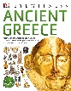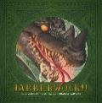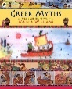

**Physical Education:**

P.E. is a vital part of our curriculum, a government requirement and a subject our children enjoy. However, to ensure children are able to fully participate, it is vital that children remember their PE kit.

Although we understand some children wear their P.E. kit to clubs, their kit should be in school **every day**.

Below is a reminder of the P.E. days for Year 4.

|  |  |  |  |
| --- | --- | --- | --- |
| **Indian Elephants** | **Hammerhead Sharks** | **Giant Pandas** | **Mountain Gorillas** |
| **Wednesday**  **Friday** | **Thursday**  **Friday** | **Wednesday**  **Thursday** | **Thursday**  **Friday** |

**Homework:**

Than you to all the parents already supporting with homework. Parent support is crucial to a child’s education and by working together, we can support your child to make great progress.

In Year 4, homework consists of a weekly Mathematics (My Maths online) and an English task (paper sheet). Both are set on a Monday and due in the following Monday.

5 ‘rule breakers’ or tricky words will be sent home on a Monday on a spelling label. We also ask that you continue to practise times tables recall with your children regularly and continue to use TT Rockstars.

Finally, we ask that you ensure they are reading either a school book or a book from home at least 3 times per week and that this is recorded in their reading record and signed by an adult.

This half term children will be completing a scratch coding. If children wish to explore this further, it can be accessed for free on:

https://scratch.mit.edu/

If you have any questions or concerns, do not hesitate to contact your child’s teacher.

**Thank you.**

**Thank you!**

.

**Online Safety:**

**With the ongoing COVID situation, we are aware that many children are spending longer online. Please ensure children are being regularly monitored and if you have any questions or concern please ask your child’s class teacher. Alternatively the school are happy to give advice if requested.**

**KEY DATES:**

**Week commencing 10th January:** Friendship week

**Friday 28th January:** Healthy Eating day (Year 4 only)

**Tuesday 8th February:** Safer Internet day

**Friday 18th February:** Nepali day